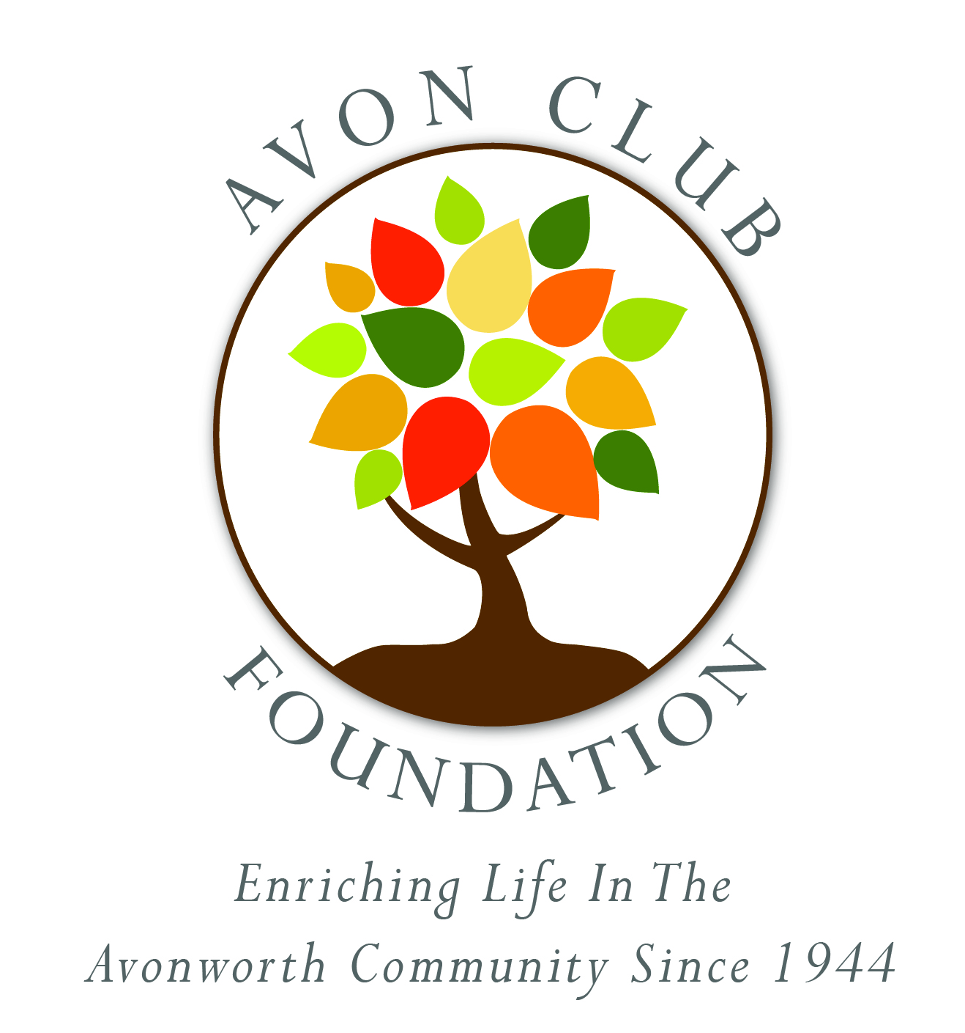

AVON CLUB FOUNDATION APPLICATION FOR FUNDS

The Avon Club Foundation is organized and operated for the charitable and educational needs of the Avonworth Community. The Foundation makes distributions to those organizations serving our community, as well as other worthy, tax-exempt organizations providing services which otherwise might be unavailable or requiring additional support from local or federal government programs. The Avon Club Foundation serves the Community defined as the area and people living within the Avonworth School District. Goals to improve the Community through projects funded by the Avon Club Foundation include:

• Education
• Recreation
• Preservation and the Environment
• Social Responsibility

February 29, 2020 - Applications Due
May 2020 - Anticipated Disbursement
Application processing will take a minimum of 50 days.
No late applications can be accepted
Please note there is only ONE disbursement for 2020

Completed applications should be sent to:
Avon Club Foundation
Attn: Finance Committee
Ben Avon Borough Hall, 7101 Church Ave,
Pittsburgh, PA 15202;

or emailed to
finance@theavonclub.org

Questions about applications or pending requests must be directed by email or telephone to:
Sheila Talarico, Avon Club Finance Chairperson
finance@theavonclub.org or 412-327-7178

Please note that your application is not complete until you receive a confirmation email from finance@theavonclub.org.

2020 AVON CLUB FOUNDATION
APPLICATION FOR FUNDS

Please complete the application, attaching no more than one additional page if needed.

2020 Application due February 29, 2020

Name of Organization ______________________________________________________________________

Contact Person Name & Position/Title_________________________________________________________

Address__________________________________________________________________________________

Phone ______________________________ Email________________________________________________

Date Application Submitted_______________________ Date Funds Needed________________________

Funding Amount Requested ___________________ Total Project/Program Cost _____________________

Endowment Area Alignment:

Education Recreation Preservation and the Environment Social Responsibility

Who will benefit from the requested funds, and how will this serve our Avonworth Community?

What, specifically, will the funds be used for?

If other funding for the program/project has been applied for or secured, please list source and amount:

If request for funds is approved by the Avon Club members, please provide appropriate:

Organization name_________________________________________________________________________

Organization address _______________________________________________________________________

